Case 3-ME-Anatolia-Bronze Age Idol-Kusura type-5000 BCE

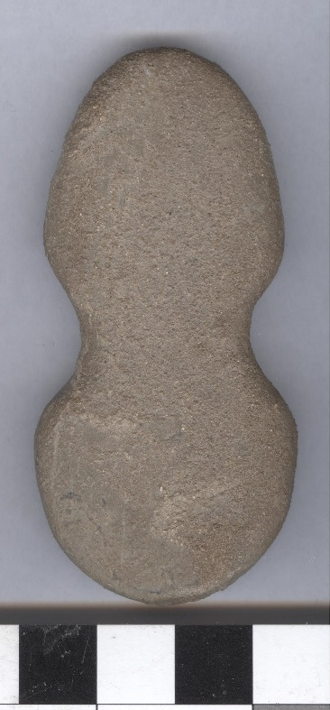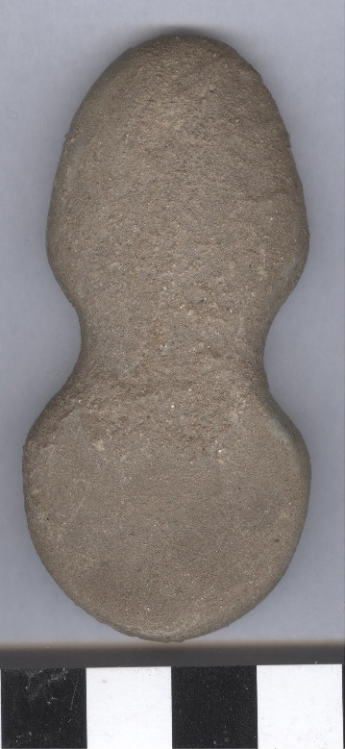

**Anatolian Bronze Age Idol of the Kusura type**

**Formal Label: Anatolian Bronze Age Idol of the Kusura type**

**Display Description:** This unusual abstract idol was made from silicified sandstone in a typical shape popular in Bronze Age Anatolia of the so-called "Kusura type". The name of this idol type refers to Kusura, an archaeological excavation in modern Turkey. There, in layer II, several comparable idols were found. Since then, we now have evidence for the popularity of these strongly stylized idols from the western coast of Asia Minor far into the inland (Schmidt and [Schliemann](http://www.worldcat.org/search?q=au%3ASchliemann%2C+Heinrich.&qt=hot_author) 1902: 279, No. 7520). The shape of this evenly thick plate with finely ground edges, has a top part more elongated and the bottom part more circular. The intersection of the two halves is the dividing line between the “head” and the “body” (Mellinck 1967: 254, plate 77, fig. 13).

**Accession Number:**

**LC Classification:**

**Date or Time Horizon:** 2700 - 2100 BCE

**Geographical Area: Kusura, Turkey**

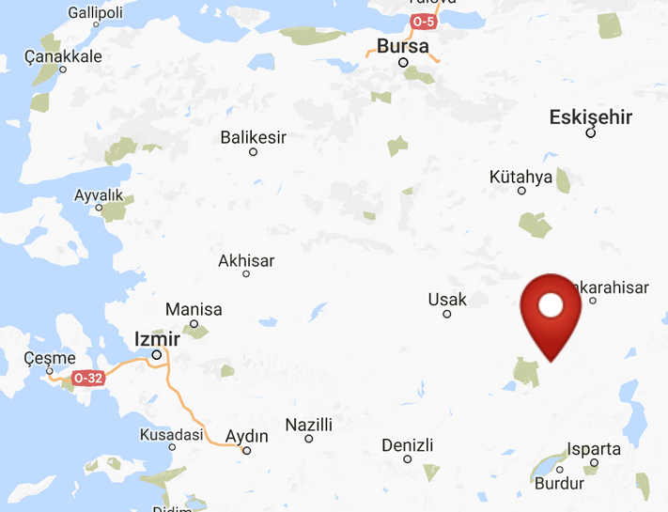

**Map, GPS coordinates: 38.36565 30.22803;** 40° 26' 46" N 79° 58' 56" W

**Cultural Affiliation:**

**Medium:** crystalline limestone

**Dimensions:**

**Weight:**

**Condition: original**

**Provenance:** Found in the Near East. Acquired by Victor Copeland in the 1950s. Later acquired by C. Sawyer.

**Discussion:** The idol was inspected and confirmed to be authentic by the late Prof. Lambert, University of Birmingham.

**References:**

Schmidt, Hubert and [Heinrich Schliemann](http://www.worldcat.org/search?q=au%3ASchliemann%2C+Heinrich.&qt=hot_author). 1902. *Heinrich Schliemann's Sammlung Trojanischer Altertümer.* Berlin: G. Reimer.

|  |  |
| --- | --- |
|  |  |

Zaal haas, *Idole*, pp. 42ff. and p. 30, plate 6.

Prähistorische Staatssammlung München, Inv.nr. 1984, 3405 and 1984, 3406 and 1984, 3407.

Mellink, Machteld J. 1967. Excavations at Karataş-Semayük in Lycia, 1966. American Journal of Archaeology, 71(3): 251-267.

Value; Ca. 1,500 USD.